**BS QUALIF FLUTTER**

Repository link: <https://github.com/joheee/qualifFlutter>

1. **Login page**

The login page will prompt user to input their username and password, with not empty validation, username must be 4 characters minimum, and password must be 5 characters minimum.

1. **Home page**

After the user has successfully login, the application will redirect user to the login page. The login page consists of a sidebar, carousel, and the displayed items. If the user clicks the logout button at the sidebar, it will take the user back to the login page. The displayed items also clickable, and will redirect user to the detail page.

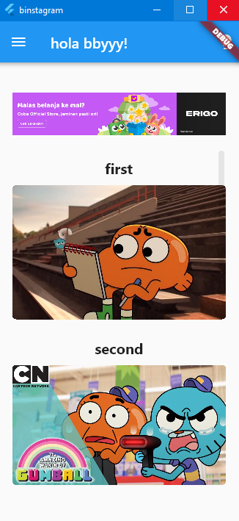

1. **Item page**

The item page consists of all the photo collection that have been displayed in the home page. If the user clicks it, it will redirect them to the detail page. At the top part of the item page, right behind ‘Debug’ letter, we can see a light bulb button, if the user clicks it, the dark/light mode will be triggered.

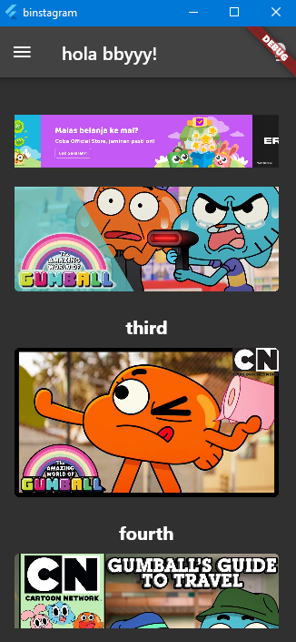

1. **Detail page**

In the detail page, the user will set one of the photo collections that they have clicked at the item page. It consists of the two-tab bar, which is detail bar and comment bar. If the user clicks the comment bar, it will slide the page to the comment section. Each bar has the comment text field, and it armed with the must filled validation.

